1. **Agenda**:
   1. What is debugging?
   2. How to run program in debugging mode?
2. Debugging can be a lot of things.
3. But specifically speaking, debugging is a process by which we can look for the issues in our code to detect them and find a way to resolve them.
4. Place a breakpoint just right to the line number. 🡸 These are lines **breakpoints**.
5. **Breakpoints**: Places in editor where execution of program gets paused in debug mode.
6. When a program is run in debug mode, the debugger window gets activate.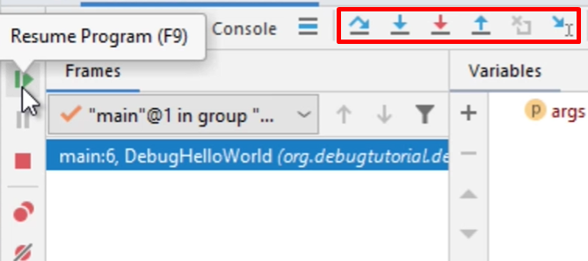
7. 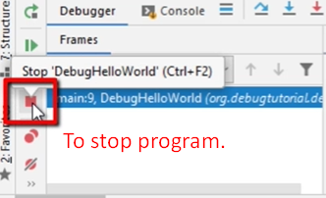
8. 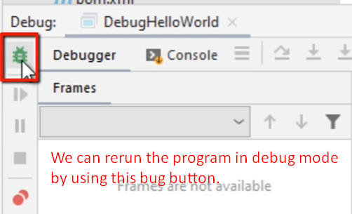
9. We saw
   1. How to run a program in debug mode.
   2. How to get paused when a breakpoint is placed.
   3. How to resume the program in debug mode.
   4. How to rerun the code in debug mode.